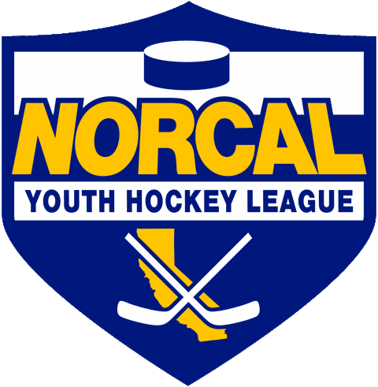
Northern California Junior Hockey Association Board Meeting
November 17th, 2020 @ 7:15pm –Via ZOOM
Meeting called to order @ 7:18pm by Dan Granata. Quorum was determined. Introductions made.
Approval of November Minutes- Motion made to approve October minutes by Chi Tse, second by Alison Bailey.
Minutes approved.
ATTENDANCE:
Name | Club or Roll | In Attendance
Dan Granata/PRESIDENT | NORCAL President | X
Laura Cahn | NORCAL General Manager | X
Suzanne Spradling | NORCAL Vice President | X
Dana Olenak | NORCAL Secretary | X
Robert Grande | NORCAL Treasurer | X
Tyler Shaffar | NORCAL Scheduler
Chris Hathaway | NORCAL Member-at-Large | X
 | NORCAL Goalie Development
Teresa Attebery | PACIFIC DISTRICT/ Roster Manager | X
Darren Attebery | NORCAL Mite Coordinator
Andy Dickerson | NORCAL Webmaster
Mark Mauro | NORCAL Referee-in-Chief | X
 | NORCAL SafeSport
 | NORCAL Director of Coaches
Todd Llewellyn | IHONC President | X
Chris Hathaway | Cupertino - President | X
Adrian Smith | Fresno – President | X
Alison Bailey/Hannah Hannon | Black Stars -President | X
Chi Tse | Oakland Club President | X
Jason Stiles | Roseville Capital Thunder - President | X
Chris Clima | Santa Clara – President | X
Robert Savoie | San Jose - President / Proxy | X
Chris Petrus | Santa Rosa Club President | X
Blaine Machart | Stockton –President | X
Ken Wood /Leticia Dries | Tahoe Grizzlies -President | X
Cameron Higley | Tri-Valley - President | X
George Caliando/Mark | San Francisco - President | X
Larry Cahn | Vacaville Jets-President | X
William Stone | GSE | X
OTHERS IN ATTENDANCE
Billy Durrett
Frank Castronovo-SC
Bill Palter
Tom Hancock-CAHA President

PRESIDENT –Dan Granata
- Governor to make announcements regarding youth sports guidelines within the next 2 weeks.
- Discussion took place regarding with Adrian Smith/Fresno regarding a 14U player movement issue. Previously played in Fresno, went to play is Stockton, has requested to move back to Fresno/play up.
- Motion made by Larry Cahn, second by Cameron Higley to approve Fresno’s player move/play up request. Motion passed.

- TRYOUTS
  - We have moved back into Purple. No on ice tryouts to be held. Hold Digital signing. Recommending practice only contract. Can add games/tournaments as approved.
  - As soon as return to play can happen-we will get a schedule going.
  - In depth discussion took place regarding the pros/cons of digital signing and permanent/tournament rosters.
  - Motion made to allow A/BB/B tryouts by digital signing beginning @ 5:00pm on December 11th, 2020 by Chris Hathaway, second by Cameron Higley. Motion approved.

- CAHA UPDATE
  - $20 CAHA Club fee (membership). Please take care of asap for those that have not yet paid.
- Season Updates:
  - Will update as things progress.
- Select Camp:
  - On ice portion looking bleak, USA Hockey wants list provided from last year’s list of candidates.
  - Players who have moved out of district are not qualified for NORCAL Selects. Would have to apply and play in their current district.
- Proposed Path Forward:
  - Continue towards tryouts. Practice as permitted. Form digital teams.
- Bill Palter:
  - Todd Llewellyn retiring as of January 1st, 2021. IHONC will be transitioning to a new organization.
  - Bill Palter (current senior official) has stepped up and is creating this new organization for NORCAL. Getting lots of input from USA Hockey and current officials.
  - Should not see much change, working towards a smooth transition. Will be using IHONC’s existing website.
  - New contract will be sent out. Any questions/concerns: palter@timetoscore.com.
  - 9 Referee seminars have been held. Currently have 117 officials. Numbers are low, more are needed. Aged out youth players make great referees!
  - More (virtual) seminars to be added.

- Billy Durrett/NORCAL GDC:
  - Billy introduced by Dan Granata. Welcome to NORCAL hockey!
  - Billy’s contact info: unbillyavble@gmail.com
  - Billy has been coaching since the early 90’s.
  - Ways he works with NORCAL:
    - Helps to deliver the goalie clinics to NORCAL.
    - Will help as requested, rinks and team sponsored goalie events.
    - Available to work with your club goalie coaches to train, and also develop programs for your goalies.
    - Developing goalie training/drill programs. “Goalie Development Sheets”.
    - Goaltending Development Leaders- Looking to assist as available, help with clinics, goalie events, goalie camps. USA Hockey goalie training provided.
    - Please feel free to reach out to Billy anytime.

GM UPDATES-Laura Cahn
- Working on Manger’s Meeting. Will be basic rules/COVID info. Expect mid-December.

FINANCIALS-Robert Grande
- No changes.
- Team Fees: Normal: $800, Reduced Fee for now: $100, due upon receipt of invoice. May prorate at a later date if play begins.

REGISTRAR UPDATES- Teresa Attebery-
- Keeping in touch with registrars.
- Will not be approving rosters until the $20 CAHA fee has been paid.
- Joint CAHA/NORCAL registrars meeting in the planning stages.

IHONC-Todd Llewellyn-
- Todd is retiring as of January 1st, 2021. Bill Palter will be taking over.
- Thank you Todd for all of your service to Northern CA hockey!

MITE JAMBOREE-Darren Attebery-NO REPORT
- Currently no travel. When able to travel, CAHA approved 3 states to travel to: Utah, Nevada and Arizona.
- Will begin planning when play opens up.

OLD BUSINESS

NEW BUSINESS

DISCUSSIONS

Closing
Meeting adjourned @ 8:27pm motioned by Chi Tse, second by Chris Hathaway.

- Next Meeting Dates:
  - TBD

