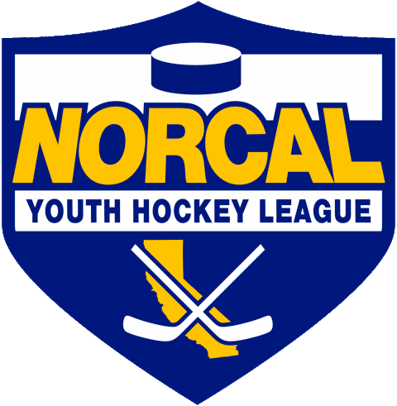
Northern California Junior Hockey Association Board Meeting
June 23rd, 2020 @ 10:00am –Via ZOOM
Meeting called to order @ 7:03pm by Dan Granata. Quorum was determined.
Introductions made.
Approval of November Minutes- Meeting minutes approved by Blaine Muchart, second by Chris Petrus.
ATTENDANCE:
Name | Club or Roll | In Attendance
Dan Granata/PRESIDENT | NORCAL President | X
Laura Cahn | NORCAL General Manager | X
Suzanne Spradling | NORCAL Vice President | X
Dana Olenak | NORCAL Secretary | X
Robert Grande | NORCAL Treasurer | X
Tyler Shaffar | NORCAL Scheduler | X
Chris Hathaway | NORCAL Member-at-Large | X
Chip Cormier | NORCAL Goalie Development
Teresa Attebery | PACIFIC DISTRICT/ Roster Manager | X
Darren Attebery | NORCAL Mite Coordinator | X
Andy Dickerson | NORCAL Webmaster
Mark Mauro | NORCAL Referee-in-Chief | X
 | NORCAL SafeSport
Mike Janda | NORCAL Director of Coaches
Todd Llewellyn | IHONC President | X
Chris Hathaway | Cupertino - President | X
Darren Redmond/Suzanne Spradling | Fresno – President | X
Alison Bailey/Hannah Hannon | Black Stars -President | X
Chi Tse | Oakland Club President | X
Jason Stiles | Roseville Capital Thunder - President | X
Chris Clima | Santa Clara – President | X
Robert Savoie | San Jose - President / Proxy | X
Anne Woida/Chris Petrus | Santa Rosa Club President | X
Blaine Machart | Stockton –President | X
Ken Wood /Leticia Dries | Tahoe Grizzlies -President | X
Cameron Higley | Tri-Valley - President | X
George Caliando/Mark | San Francisco - President | X
Dana Olenak Proxy | Vacaville Jets-President | X
OTHERS IN ATTENDANCE
William Stone – Tri Valley
Frank Castronovo-Santa Clara
Tom Hancock-CAHA
Dave Curtis-Tri Valley
Wade Gilbert-Fresno
Scott Roberts-Santa Clara
Suzanne Spalding-Fresno

PRESIDENT –Dan Granata
- Welcome everyone.
- Rinks: Some are opening up by appt only. Vacaville explained their opening up process and how they are working within the limits and guidelines. Its not sustainable, but working so far.
- Dan reached out to several regarding the VP position. Suzanne Spradling from Fresno has accepted the position for the remaining 1 year term.
- Motion made by Chris Hathaway, second by Chi Tse for Suzanne Spradling to take over the VP position for the remaining 1 year term. Motion passed.

- Season Updates/Plan B/Modifications
  - Games most likely will not occur or should not occur during social distancing.
  - Discussed beginning training camps in anticipation to the start of a late season date. (after vaccine etc.)
  - CAHA to set date in July for special meeting regarding any state championships.
  - If August tryout dates CANNOT be met AAA & AA seasons may not be long enough for complete seasons.
  - Suggestion made by William Stone to proceed with option for season (A, B and C) depending on meeting virus checkpoints.
  - Tom Hancock stated if things go backwards in CA with COVID, CAHA will step in and make a decision about the season.
  - Dan, with help from the rinks, will draft up A, B and C season scenarios/plans.

- Mite Coordinator/Stipend
  - Dan recommended the board plan/approve a stipend for the Mite Coordinator position.
  - Robert to figure into the yearly budget – amount of $1500-$1800.
  - Will add job description, and include more communication with clubs.
  - Motion made by Larry Cahn, second by Chi Tse to pay the Mite Coordinator a stipend not to exceed $1800. Motion passed.

- 14U Non-Check/17U 2021-2022
  - Thoughts?
  - Larry Cahn discussed there was probably a spot. Was unsure about NORCAL’s numbers and viability. Blaine Muchart agreed with Larry. Tom/Oakland thought it was an interesting idea and worth considering.
  - Chi Tse commented they have a non-check division and has had several conversations with Shane.
  - Teresa noted that 2021 will be a rule change year. Transition will be to 17U, 18’s will have to play adult or Jr’s to continue playing.

- USA Hockey Numbers
  - Membership numbers with USA Hockey are down 60% this year.
  - Probably due somewhat to late tryouts, 14’s not coming back, COVID.
  - William questioned if CAHA would be keeping the same format? No change per Tom Hancock. Prior to COVID options were being explored, but currently tabled until next season.

- SafeSport Update
  - Dan to send out Zero Tolerance document with the new language added.

- New NORCAL Zoom Account
  - NORCAL has purchased a ZOOM account. Email Dan if you would like to use.
  - Emails: Board now has email addresses attached to NORCAL acct.

GM UPDATES-Laura Cahn-
- Managers Meeting
  - TDB, will be scheduled when season is able to begin. Will be by ZOOM, and recorded/posted on website for future viewing.

FINANCIALS/Robert Grande-
- Bylaws Update
  - Completed and done.
  - Will get posted to website.

- Budgets
  - Will begin working on budgets.
  - Mites may have a change to cover the new the Mite Coordinator Stipend.

- Movement of Mailing Address
  - Will be opening up a new mailing address for NORCAL. Will update with the new address.

REGISTRAR UPDATES- Teresa Attebery-
- Zero Tolerance
  - Will send out along with some other info for the 21-22 season, changes to levels.
  - Tier 1 & 2/Level 4 & 5 changes to continuing education. Work in progress.

- Participation in NON USA Hockey Events
  - NON USA Hockey sanctioned events are only current events happening. USA Hockey is not approving any events currently.
  - No final decision regarding USA Hockey and any sanctioned tournaments this year. Be aware of where you play and social distancing issues.

- Background Checks
  - Coaches and officials can log in and check their own screening status.

- Registrars Meeting
  - Registrars meeting will take place on ZOOM for new registrars. New portal to be released by early July-no changes.

IHONC-Todd Llewellyn-
- No updates.
- Still waiting to hear about possibility of officials to certify online.
- Only about 60% of officials expected as of this date willing to come back.
- Larry Cahn made suggestions to tap into hockey dads, adult league, aged out 18’s to step up this year to become referees due to shortage.

MITE JAMBOREE-Darren Attebery-
- Thank you for the stipend.
- Will go over possible dates next meeting.
- Will include club presidents in future communications through Team Snap.

OLD BUSINESS
- Contact Listing-Contact listing has been updated.
- https://docs.google.com/spreadsheets/d/1U8XJjSXTRc-L9xJRwGzxs40RpLhx70rhnSridDXY1P0/edit?usp=sharing

NEW BUSINESS

DISCUSSIONS

Closing
Meeting adjourned @ 8:34pm. Motioned by Robert Grande, second by Chris Hathaway.

- Next Meeting Dates:
  - CAHA Special Meeting to be held approx. July 30th
  - NORCAL Board meeting July 18th, via ZOOM.
  - August TBD
  - September TBD

