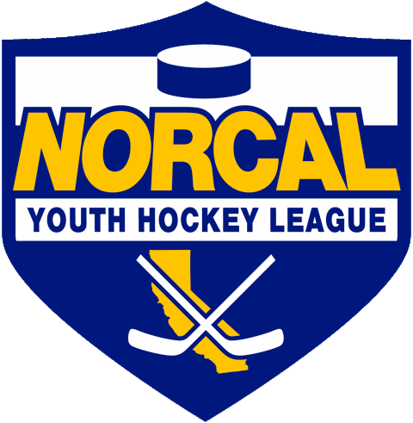
Northern California Junior Hockey Association Board Meeting
January 11th, 2020 – Stockton Arena/Also Via ZOOM
Meeting called to order @ 10:4am by Matt Adams. Quorum was determined.
Introductions made.
Approval of November Minutes- No November Meeting Minutes. Will forward via email accordingly for approval.
ATTENDANCE:
Name | Club or Roll | In Attendance
Matt Adams | NORCAL President | X
Laura Cahn | NORCAL General Manager | Zoom
Dan Granata | NORCAL Vice President | X
Dana Olenak | NORCAL Secretary | Zoom
Robert Grande | NORCAL Treasurer
Tyler Shaffar | NORCAL Scheduler | Zoom
Chris Hathaway | NORCAL Member-at-Large | Zoom
Chip Cormier | NORCAL Goalie Development
Teresa Attebery | PACIFIC DISTRICT/ Roster Manager
Darren Attebery | NORCAL Mite Coordinator
Andy Dickerson | NORCAL Webmaster
Mark Mauro | NORCAL Referee-in-Chief
Jeff Blair | NORCAL SafeSport
Mike Janda | NORCAL Director of Coaches
Todd Llewellyn | IHONC President | Zoom
Chris Hathaway | Cupertino - President | Zoom
Jeff Ferguson | Fresno – President | X
Alison Bailey | Black Stars -President | X
Chi Tse | Oakland Club President | X
Dan Granata | Roseville Capital Thunder - President | X
Chris Clima | Santa Clara – President | Zoom
Vaughn Reuter | San Jose - President / Proxy
Bridget Pauland/Proxy | Santa Rosa Club President | Zoom
Blaine Machart | Stockton –President | X
Ken Wood | Tahoe Grizzlies -President | Zoom
Cameron Higley | Tri-Valley - President | Zoom
George Caliando | San Francisco - President | X
Dana Olenak Proxy | Vacaville Jets-President | Zoom
OTHERS IN ATTENDANCE

PRESIDENT –Matt Adams

- House vs House Games/Draft Presentation-
  - Went over some ideas/presentation on what a house vs. house league would look like. It would run parallel to NORCAL league. Suggest 45 minute games, 3 at same location, ¾ clubs at a time-maybe structured like a regional jamboree. The point of this league would be to serve a group of players not yet ready for travel but wanting to play more games/team variation/be challenged.
  - Pricing is concern. Needs to be easy for families. Needs to be structured with rules/perimeters.
  - Laura suggested maybe seeking the help of CAHA to lighten rules so that more work is not created. More flexible teams. CAHA rules govern house. Rule: Must have a USA Hockey roster to play outside of the home rink, then follow age requirements etc.
  - Matt to research rules further, dates, possible perimeters. Will have something prepared for March meeting.
  - Will look at the possibility of including Reno.
  - Possibly condense NORCAL schedule to NOV-MAR, House SEPT-OCT.
  - Bridget/Santa Rosa offered to help with player retention side.
  - Needs to be more structured than regular house, representing the next level before Travel.
  - Chris Hathaway brought up that Tyler would have to structure/work the schedule more. Possibly could follow hoe he structures the Mite Jamborees.
  - Direction of 10U is moving to half ice.
  - You could still schedule exhibition games in addition to your house league schedule.
  - Cameron voiced that the house league would need very defined perimeters and needed to be kept structured.
  - Suggestion made to add a House League Coordinator/Regional Coordinators to manage league.
  - Chi Tse questioned why a rink can’t just hold a tournament instead of getting NORCAL involved and governing house.
  - This new Hose League is not meant to be another NORCAL travel league but a stepping stone.
  - Matt to include to agenda for March meeting a listing of the HS committee/group.
  - Rec League for smaller outline clubs harder to run.

GM UPDATES-Laura Cahn-

- Selects #’s- Total paid players for selects: 197.
- Laura and Teresa will be there for Selects check-ins.
- Discussion took place regarding player who moved to Canada, unable to make a team, stayed in Canada. Played for SJ 16AA for 8 games and rostered as 3rd goalie. Dad contacted Laura about how to include out of district players for Selects. Laura sent to CAHA. CAHA will refer them for a district waiver. Player would need to play at district level, not NORCAL or CAHA. Motion made by Jeff Ferguson, second by Cameron Higley to include player in question at the NORCAL level in tryouts at the Selects Camp. MOTION IS DENYED.

- Playoff Divisions Per Venue:
- Motion made by Cameron Higley, second by Chris Hathaway to approve proposed playoff locations per division as follows:
San Jose: Vacaville:
16A 14B Flight 1
14A 12BB
14B Flight 2 12B
12A 10BB
10A 10B
MOTION PASSED.

- Tryout Dates for NORCAL, recommend the Weekend of June 12th, 2020
- NORCAL TRYOUT DATES: (coincide with CAHA, dates were approved in November) Will be adding to NORCAL website.
- Tier l: May 29th, 2020
- Tier ll: June 5th, 2020
- A/B/BB/HS: June 12th, 2020
- Laura to send out email regarding the structure of the Girls tryouts for 2020-21 season so there is no confusion.
- Motion made by Cameron Higley and second by Chi Tse to set NORCAL tryout dates to begin no earlier than: (from NOV meeting)
- Tier l- Youth/Girls – May 29th, 2020 – Motion passed
- Tier 2 – Youth/Girls – June 5th, 2020 – Motion passed
- A/BB/B & HS – Youth and any girls team in NORCAL/playoff eligible– June 12th, 2020 – Motion passed.

FINANCIALS/Robert Grande-
- NO REPORT

REGISTRAR UPDATES- Teresa Attebery-
- NO REPORT

IHONC-Todd Llewellyn-
- NO REPORT

MITE JAMBOREE-Darren Attebery-
- NO REPORT

OLD BUSINESS
- Contact Listing-Contact listing has been updated.
- https://docs.google.com/spreadsheets/d/1U8XJjSXTRc-L9xJRwGzxs40RpLhx70rhnSridDXY1P0/edit?usp=sharing

NEW BUSINESS
  - Chi Tse/Oakland: Will be under going rink retrofit. Will be requesting CAHA Approval for earlier tryout date.
  - Blaine Muchart: Oak Park Ice/Stockton will also be undergoing rink retrofit. Will be requesting earlier tryout date.

DISCUSSIONS

Closing
Meeting adjourned @ 11:51am. Motioned by Dan Granata, second by Cameron Higley.

- Next Meeting Dates:
  - March 7th, 2020/TBD
  - April 25th, 2020/Holiday Inn Express

